Please follow the steps in order to set up and test the configuration of SDN using Frenetic.

This activity can be carried out in two ways :

Type A:

1.To set up VirtualBox download and install from the link given

link - <https://www.virtualbox.org/wiki/Downloads>

2. Download the [Mininet VM image](https://github.com/mininet/mininet/wiki/Mininet-VM-Images) from

link - <https://github.com/mininet/mininet/wiki/Mininet-VM-Images>

3. Importing the Mininet VM image in VirtualBox

3.1 Clicking on the File > Import Appliance Option

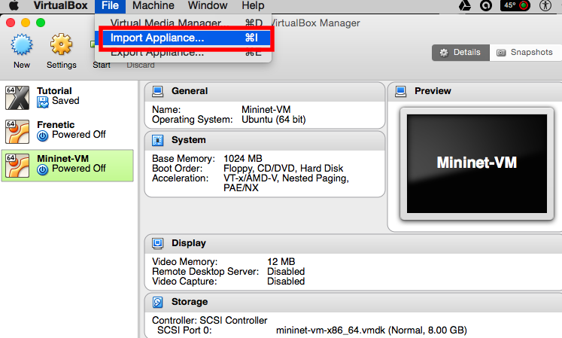

3.2 Browsing the Mininet VM Image

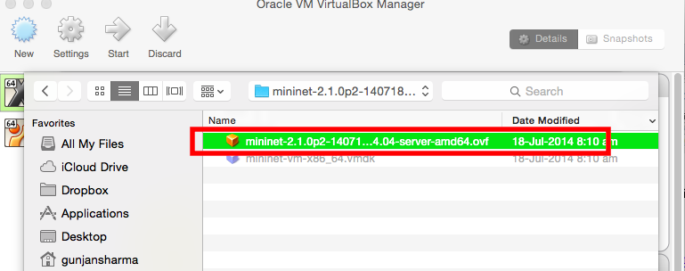

3.3 Click Continue > Finish and you should see something similar to the below screen

4. Click on Start to start the VM by clicking on the Green Arrow as highlighted below.

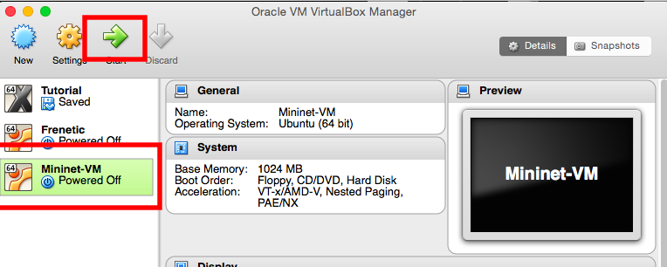

5. When the VM boots up, a Black window will appear which will ask for a username and password, which are as follows.

Username – mininet

Password – mininet

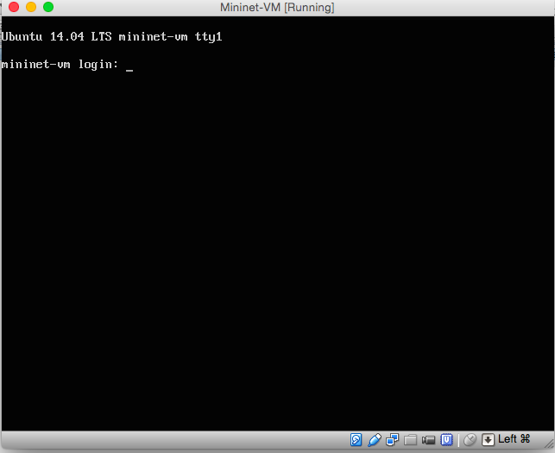

6. Install Opam by Ocalm in order to install Frenetic by following the commands in the video tutorials.

Note – If the program prompts to answer Yes/No please continue with a ‘Y’.

FYI - Installation of frenetic takes more than 20 mins because it installs 27 other dependent packages.

Commands for reference –

1. opam init (To initialize opam, however first we need to check whether opam is installed or not)
2. sudo apt-get install opam (to install opam)
3. opam init (To initialize)
4. opam update (To update any changes made to the opam package)
5. opam upgrade (To upgrade)
6. opam install frenetic (To install frenetic)

7.After frenetic is successfully installed we can run the following commands for traffic analysis.

**def web_query():**

**return \**

**(Select (sizes) * Where (inport_fp(2) & srcport_fp(80))) * Every (30))**

Type B:

1. Repeat steps 1-3 as mentioned in type A but replace the mininet image in step 2 by the following frenetic image.
   1. <http://www.cs.umass.edu/~arjun/download/frenetic.ova>
2. Within the frenetic-tutorial-code directory, you should find the repeater policy in Repeater.nc .
3. To start the repeater controller, just type:

**$ frenetic Repeater.nc**

Now, in a separate terminal, start up mininet with the default, single switch topology.

**$ sudo mn --controller=remote**

1. Test the Example

At the mininet prompt, test your repeater program by pinging h2 from h1:

mininet> h1 ping -c 1 h2

You should see a trace like this one:

PING 10.0.0.2 (10.0.0.2) 56(84) bytes of data. 64 bytes from 10.0.0.2: icmp_req=1 ttl=64 time=0.216 ms --- 10.0.0.2 ping statistics --- 1 packets transmitted, 1 received, 0% packet loss, time 0ms rtt min/avg/max/mdev = 0.216/0.216/0.216/0.000 ms